**1. Mean Time Between Failures (MTBF)**

**Definition:** MTBF is the average time between consecutive failures of a system during normal operation. It is used to predict the reliability of a system.

**Calculation:**

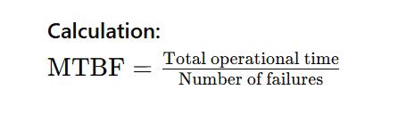

**Usage:**

* **Predictive Maintenance:** Helps in scheduling maintenance activities before the next expected failure.
* **Reliability Assessment:** Provides an estimate of how reliable a system is over time.

**Example:** If a machine operates for 1,000 hours and experiences 5 failures during that period, the MTBF is: 1000/5 = 200 hours

**2. Mean Time to Failure (MTTF)**

**Definition:** MTTF is the average time to failure for a system or component that cannot be repaired (non-repairable systems). It represents the expected operational life of the system or component.

**Calculation:**

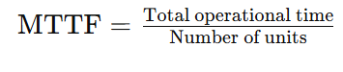

**Usage:**

* **Lifecycle Prediction:** Helps in predicting the average lifespan of a product or component.
* **Design Considerations:** Used by engineers to design more reliable systems by understanding component longevity.

**Example:** Light bulk 1 have operational life of 1000 hour, Light bulk 2 have 1200 hour then

MTTF = (1000 + 1200 ) / 2 = 1100 hours

**3. Mean Time to Repair (MTTR)**

**Definition:** MTTR is the average time required to repair a system or component and return it to operational condition after a failure.

**Calculation:**



**Usage:**

* **Maintenance Efficiency:** Measures the effectiveness and efficiency of maintenance procedures.
* **Service Level Agreements (SLAs):** Helps in defining and meeting service level expectations regarding downtime and repair times.

**Example:** If a machine experiences 5 failures and the total repair time for all failures is 10 hours, the MTTR is: 10/5 = 2hours

